# Charting the innovation startup analysis:

Introduction:

A startup analysis is essential to the success of any startup business. It allows entrepreneurs to identify the key areas that need improvement and make necessary changes early on. Doing a startup analysis also allows startups to track their progress and ensure that they are on track to achieve their goals.

a. What is a startup?

Source: NASSCOM Startup India report 2015, Secondary sources, New articles Currently a clear definition of a ‘Startup’ does not exist in the Indian context due to the subjectivity and complexity involved. Considering various parameters pertaining to any business such as the stage of their lifecycle, the amount and level of funding achieved, the amount of revenue generated, the area of operations, etc, some conceptual definitions are available in the public domain. These have been sourced and enumerated below to provide an indicative understanding on the space to the reader. The Department of Industrial Policy and Promotion (DIPP) is also working around a clear definition for startups and is expected to make it public in due course.

Overview:

Startups have been the flavour of the season over the last few years for the Indian markets. This has resulted into the emergence of a number of home grown unicorns across the country. One of the major contributors leading to this development has been the mega funding that has been ploughed into most of these unicorns between the period 2007 and 2015. This has been in line with the global trend dominating the space. Even the aspiring unicorns have had a decent run during this period, where managing to find investors is usually considered a tough task. The trends of investments suggest that investors want to enter as an early investor, even before the start of the firm. Starting a new company can be an exciting and rewarding experience, but it also requires careful planning and analysis to ensure that the business is viable and successful. There are several key areas that you should focus on when conducting a startup company analysis. Conducting a thorough analysis of these areas can help you identify potential challenges and opportunities, develop strategies to address them. It is also important to regularly review and update your analysis as the business progresses, adapt to changing market conditions

[**Purposes**](https://1drv.ms/w/s!ADNjCWFYtIzlaw):

1. Securing funding: A comprehensive startup analysis can help entrepreneurs to secure funding from investors or lenders. By demonstrating the feasibility and potential of their business venture, entrepreneurs can increase their chances of securing the necessary capital to launch and grow their startup.
2. Developing a business plan: Startup analysis can provide valuable insights and data that can be used to develop a business plan. A well-developed business plan can help entrepreneurs to articulate their vision, identify their target market, and outline their marketing and growth strategies.
3. Identifying opportunities and risks: By conducting a thorough analysis of the market, competition, and industry trends, entrepreneurs can identify potential opportunities and risks that may impact their startup. This can help them to refine their business model, pivot their strategy, or adjust their product offering as needed.
4. Evaluating performance: Startup analysis can be an ongoing process, allowing entrepreneurs to continuously evaluate their performance and refine their strategy over time. By monitoring key performance indicators, such as revenue growth, customer acquisition, and profit margins, entrepreneurs can make informed decisions and adjust their approach as needed.

Overall, startup analysis is a critical tool for any entrepreneur looking to launch and grow a successful business venture. By conducting a thorough analysis of their market, competition, and potential risks and opportunities, entrepreneurs can make informed decisions and develop a comprehensive strategy for success.

**Problem definition & design thinking:**

Empathy map

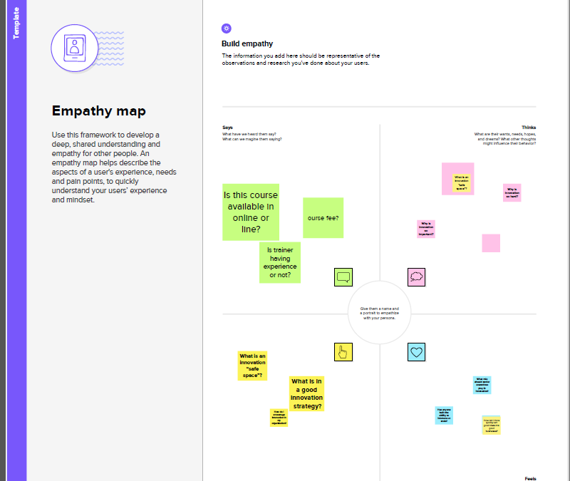

Ideation & brainstroming map

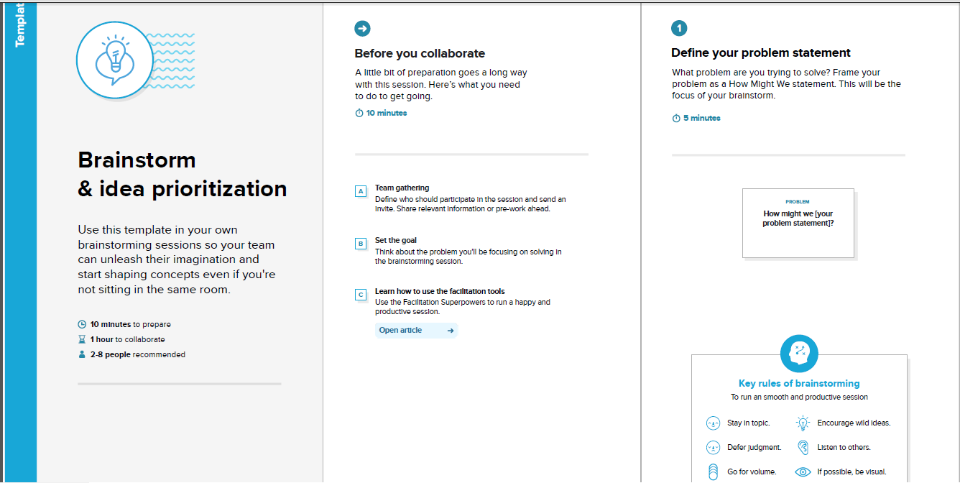

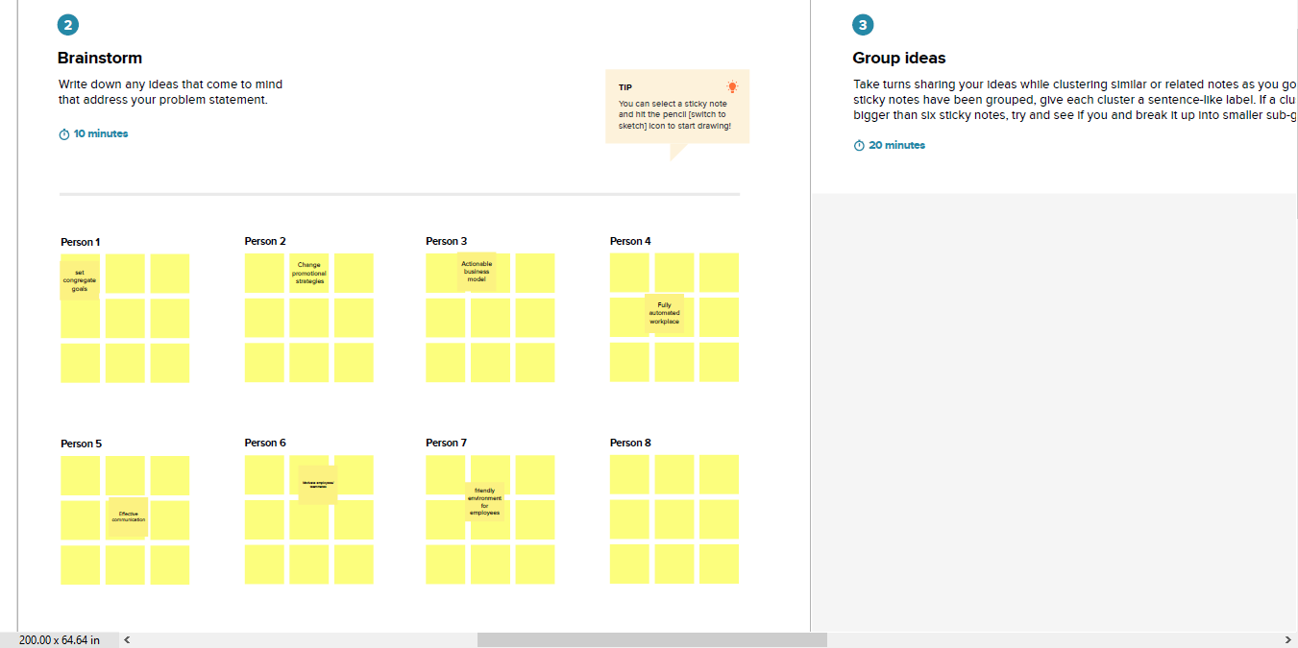

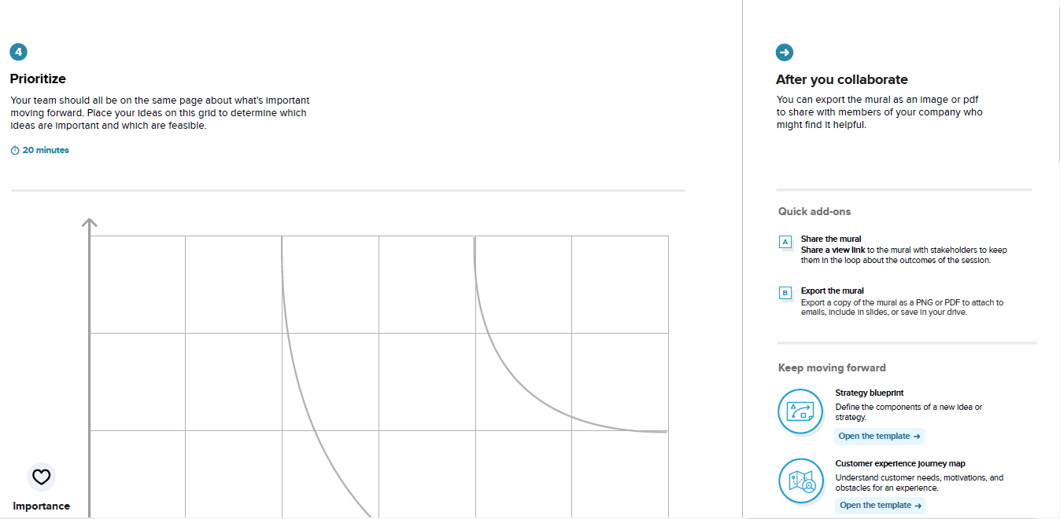

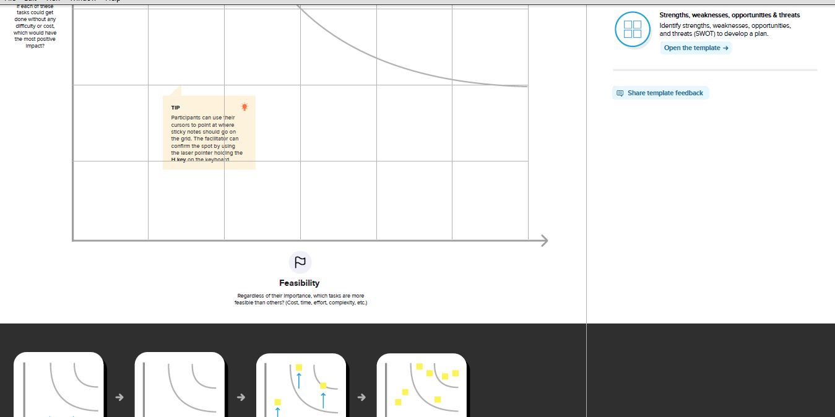

**Result**

NO OF STARTUP YEAR WISE

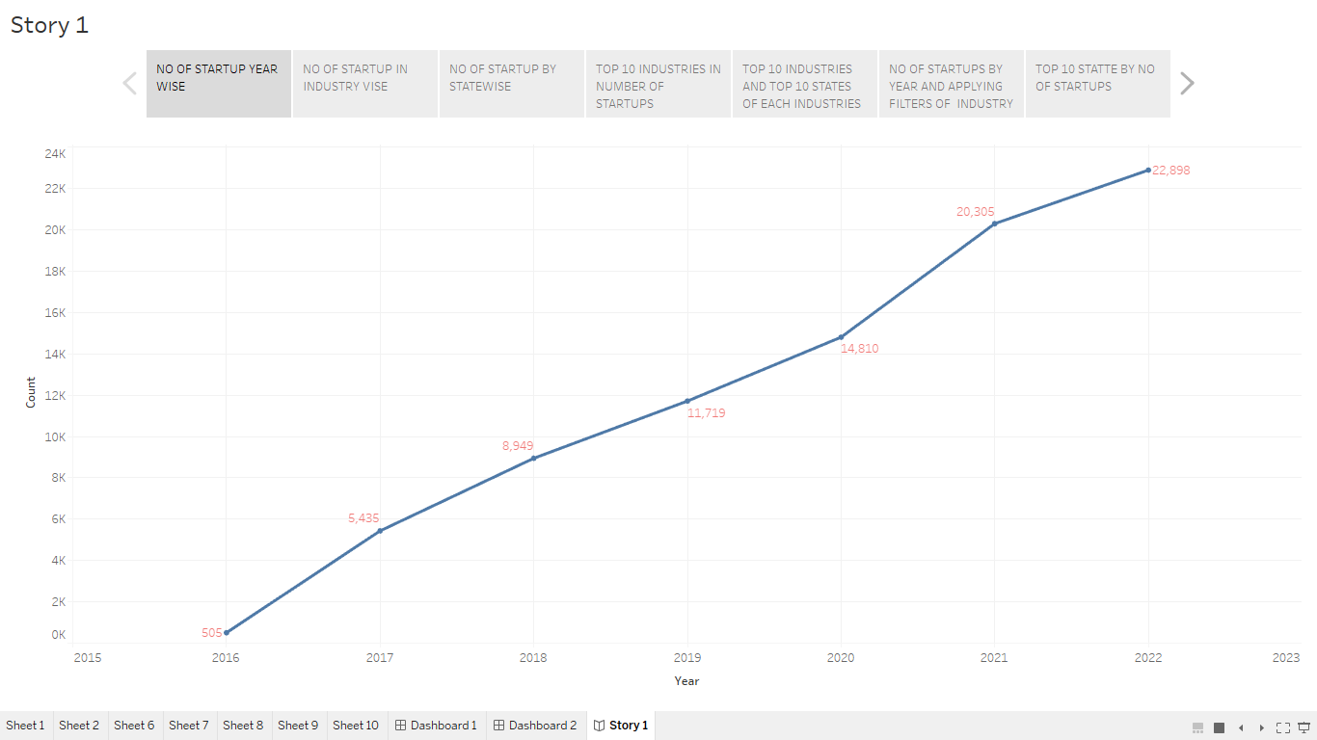

No of startup in industry wise

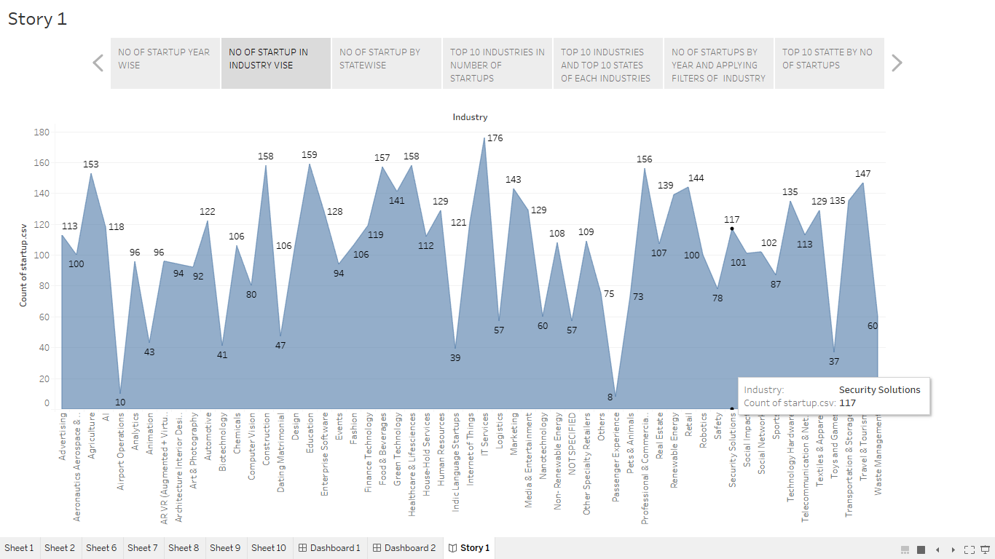

No of startup in statewise

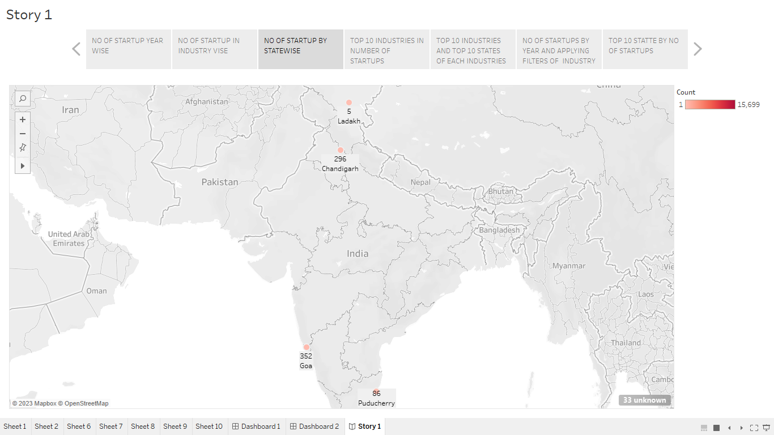

Top 10 industries in number of startups

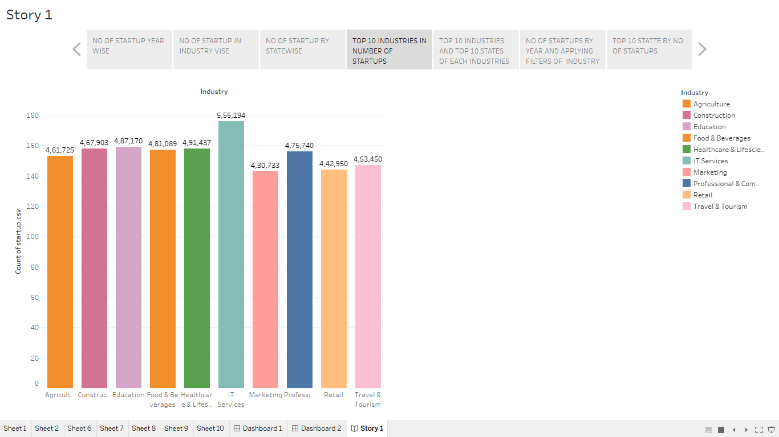

Top 10 industries and top 10 states of each industries

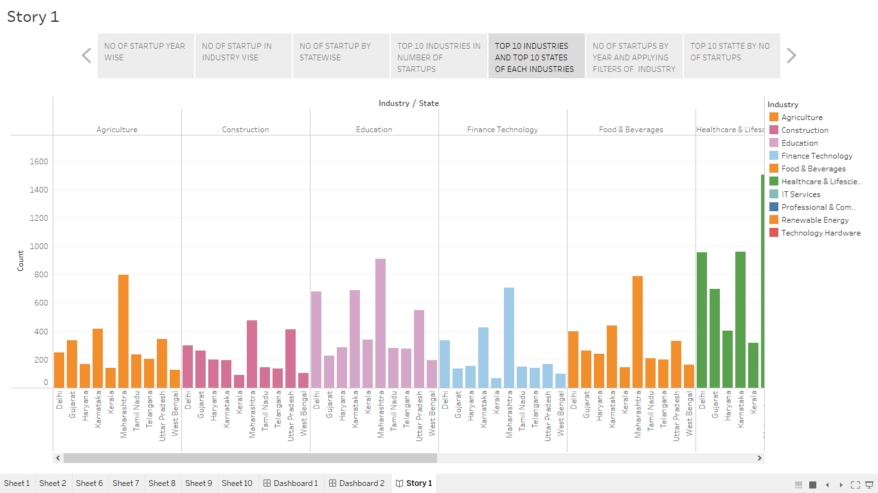

No of startups by year and applying filters of industry

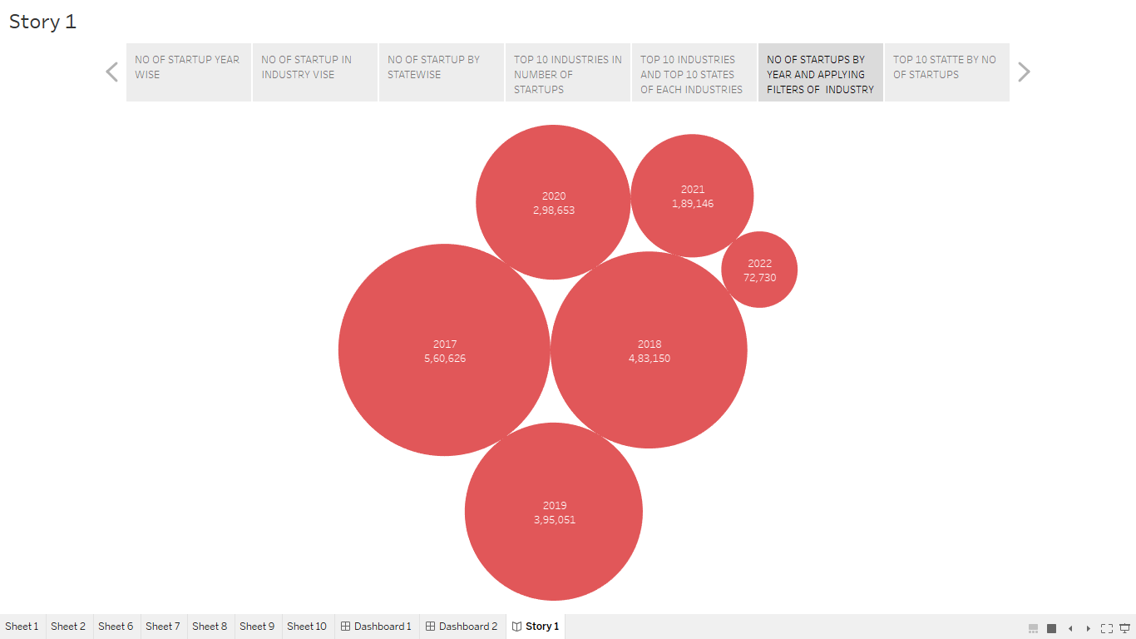

Top 10 state by no of startups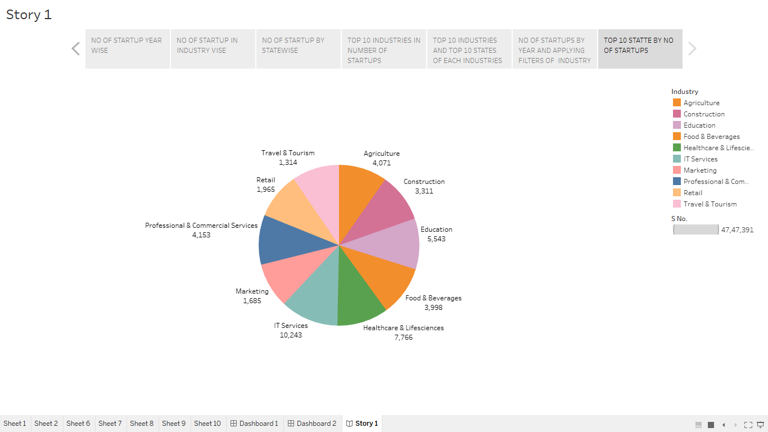

**Advantages and disadvantages:**

Advantages

* Identifying market opportunity: Analyzing the startup market can help identify new and emerging trends, as well as areas where there is a gap or unmet need. This can help entrepreneurs identify market opportunities and develop products or services to address them.
* Understanding the competitive landscape: Analyzing the competition can help startups understand their strengths and weaknesses, as well as their potential opportunities and threats. This can help them develop a competitive advantage and differentiate themselves in the market.
* Evaluating financial viability: Startups often require significant investment to get off the ground, and investors need to be confident that their investment will pay off. Analyzing the financial viability of a startup can help investors evaluate the potential return on investment and assess the risks involved.
* Assessing scalability: Many startups aim to grow rapidly and become scalable businesses. Analyzing a startup's business model and market potential can help entrepreneurs and investors assess the scalability of the business and its potential for long-term growth.
* Identifying potential risks: Starting a new business is always risky, and there are many potential pitfalls that entrepreneurs need to be aware of. Analyzing the startup landscape can help identify potential risks and challenges, allowing entrepreneurs to prepare and mitigate those risks.

Overall, startup analysis can help entrepreneurs and investors make more informed decisions and increase the likelihood of success.

Disadvantages :

* Limited data: Startups are often operating in new and emerging markets, which means there may be limited data available to analyze. This can make it challenging to accurately assess the market opportunity, competitive landscape, and potential risks.
* Uncertainty: Startups by nature are uncertain, and there is always a risk that the analysis will not accurately predict the future. Factors such as changing market conditions, unexpected competition, or unforeseen regulatory changes can impact the success of a startup.
* Bias: The analysis of a startup can be influenced by the biases and assumptions of the analyst or investor. This can impact the accuracy and objectivity of the analysis, leading to poor decision-making.
* Time-consuming: Startup analysis can be a time-consuming process, requiring extensive research and analysis. This can be challenging for entrepreneurs who are also trying to build and grow their businesses.
* Cost: Conducting a thorough startup analysis can be expensive, particularly if it requires the services of outside consultants or specialized software tools.

Overall, while startup analysis can provide valuable insights, it is important to be aware of the potential disadvantages and limitations of the process. Entrepreneurs and investors should carefully consider the costs and benefits of startup analysis before deciding to invest time and resources into it.

**Applications:**

* Market research: Startup analysis can be used to conduct market research, including identifying emerging trends, analyzing the competition, and assessing the potential size of the market.
* Investment decision-making: Startup analysis can help investors make more informed decisions about whether or not to invest in a particular startup. It can also help investors evaluate the potential return on investment and assess the risks involved.
* Business planning: Startup analysis can be used to develop a business plan, including identifying the target market, analyzing the competition, and developing a marketing strategy.
* Risk assessment: Startup analysis can be used to identify potential risks and challenges that a startup may face. This can help entrepreneurs and investors develop strategies to mitigate those risks and increase the likelihood of success.
* Innovation: Startup analysis can be used to identify areas where there is a gap or unmet need in the market, which can inspire entrepreneurs to develop innovative products or services to address those needs.

Overall, startup analysis can be applied in a variety of ways to help entrepreneurs and investors make more informed decisions, increase the likelihood of success, and drive innovation.

**Conclusions:**

In conclusion, startup analysis can be a valuable tool for entrepreneurs and investors. It can provide insights into the market opportunity, competitive landscape, financial viability, scalability, and potential risks of a startup. This information can help entrepreneurs and investors make more informed decisions, develop strategies to mitigate risks, and increase the likelihood of success.

However, it is important to be aware of the potential limitations and disadvantages of startup analysis, including the limited availability of data, the uncertainty inherent in startups, the potential for bias, the time-consuming nature of the process, and the cost involved.

Overall, startup analysis should be viewed as one part of a broader process of business planning, risk assessment, and decision-making. By using startup analysis in combination with other tools and strategies, entrepreneurs and investors can increase their chances of success in the startup market

**Future scope:**

* Increased use of data analytics: As more data becomes available, there is a growing opportunity to use data analytics to gain deeper insights into the startup ecosystem. This can include analyzing trends, identifying patterns, and developing predictive models to help entrepreneurs and investors make more informed decisions.
* Greater focus on social impact: There is a growing trend towards startups that are focused on social impact and sustainability. Startup analysis can be used to identify and evaluate these types of startups, helping investors to support businesses that are aligned with their values and priorities.
* Advancements in technology: Technology is rapidly changing the startup ecosystem, and there are many new technologies that can be used to analyze startups. For example, machine learning and natural language processing can be used to analyze large volumes of data and extract meaningful insights.
* Cross-border investment: There is a growing trend towards cross-border investment in startups, which creates new opportunities and challenges for startup analysis. Evaluating startups across different countries and cultures requires a nuanced understanding of local markets and regulations.
* Integration with other business functions: Startup analysis is increasingly being integrated with other business functions, such as marketing, sales, and product development. This can help to create a more holistic view of the startup ecosystem and enable businesses to make more strategic decisions.

Overall, the future scope of startup analysis is bright, as new technologies and trends continue to shape the startup ecosystem. As the field of startup analysis continues to evolve, entrepreneurs and investors can expect to see new tools and strategies emerging to help them navigate this exciting and dynamic market.

**Appendix:**

Tableau Public Dashboard link:

<https://public.tableau.com/views/chartingtheinnovationdashboard/Dashboard1?:language=en-US&:display_count=n&:origin=viz_share_link>

Tableau Public story link:

<https://public.tableau.com/views/chartingtheinnovationstory/Story1?:language=en-US&:display_count=n&:origin=viz_share_link>

Tableau Public project link:

<file:///C:/Users/Karthik/Desktop/Charting%20the%20Innovation%20-%20A%20Startup%20Analysis/charting%20the%20innovation%20-%20Project/index.html>

Video Link:

<https://drive.google.com/file/d/1VCMtFk4leCYNWpZ0LEUg0wu-iLJhKkUl/view?usp=share_link>